Server Setup for launching Browser-less Blood Center application with CAC
- Setup Apache Web Agent for ForgeRock.
- Edit bcoracleagentapp.ini.php file and enter db connection details. Copy the file to server location /var/www/

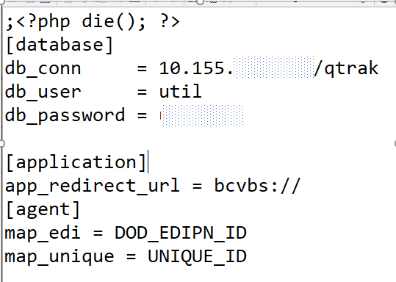

- Copy bcoracleagentapp.php to server location at /var/www/html

Client Setup (One-time) for launching Blood Center application with CAC.
- Copy BCCAC.zip to the client machine and extract it to a location.

Extract the archive to C:\BCCAC. If the zip is extracted to a different location, note down the paths for BCCAC_FSAL.bat and BCCAC_FSAL.vbs files. They are required for the next steps.

- Skip this step if the zip is extracted to C:\BCCAC.

Edit the‘ BCCAC_FSAL.vbs’ file to update the correct location of the ‘BCCAC_FSAL.bat’ file
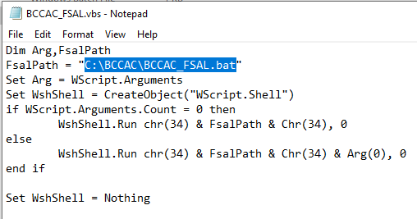

- Skip this step if the zip is extracted to C:\BCCAC

Edit the ‘regedit-bcvbs.bat’ file with the correct location of the BCCAC_FSAL.vbs file.

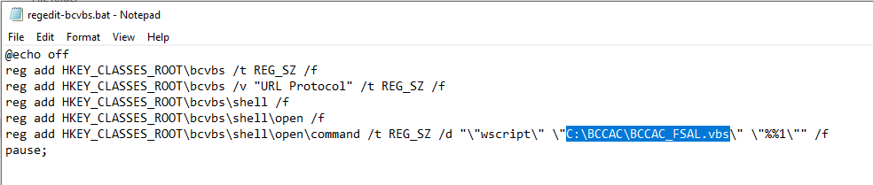

- Run the batch script with ‘Administrator’ privileges. This batch script will create a custom URL protocol on the client machine that allows a browser to launch the browser-less Blood Center Application from the browser’s address bar.

Modification History
Date | Change | By
04/04/2022 | CAC setup instructions to launch Browser-less BC 2019 application.  Release: BC 2019 R4 SP3.1 | Ashok Vardhan  Seshu Surapaneni

